



Image: Rawpixel

**Connecta**

**LEARNING PACK 3 | STORYBOARDING**



**Contents**

1.Storyboarding 1-2

1.1 Exercise 1 3

2. From screenplay to film 4

2.1 Exercise 2 4-5

3. Creating your storyboard 6

3.1 Exercise 3 6

3.2 Camera angles 6-9

3.3 Exercise 4 9

4. Adding props 9-10

4.1 Exercise 5 10-11

5. Glossary 12-13

6. Self-assessment 13

7. References 14

1. **Storyboarding**

**What is a storyboard?**

A **storyboard** is a visual representation of a film sequence, which illustrates how a story will unfold. It shows what will happen step by step in a story. Pictures, text and descriptions are drawn out to explain what you want to achieve.

A storyboarding normally follows a script. Have you finished your script? ______________

If so, you might want to explore how to do a storyboard.

**Who makes a storyboard?**

In the filmmaking industry, **storyboard artists** are employed to translate the screenplay into a visual form. Storyboard artists interpret the screenplay from a script.

**Why is storyboarding important?**

Storyboarding is one of the most important steps in pre-production. It is important because it turns your vision into pictures and can help you to plan, organise and focus your story. A storyboard is a powerful way to help you to pre-visualise your film.

Some storyboards only include images

**Here are some examples of storyboards:**

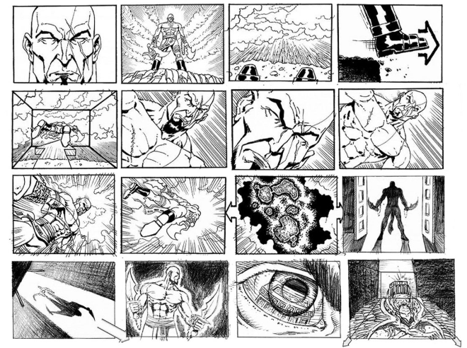

Photo credit: Tony Liberatore

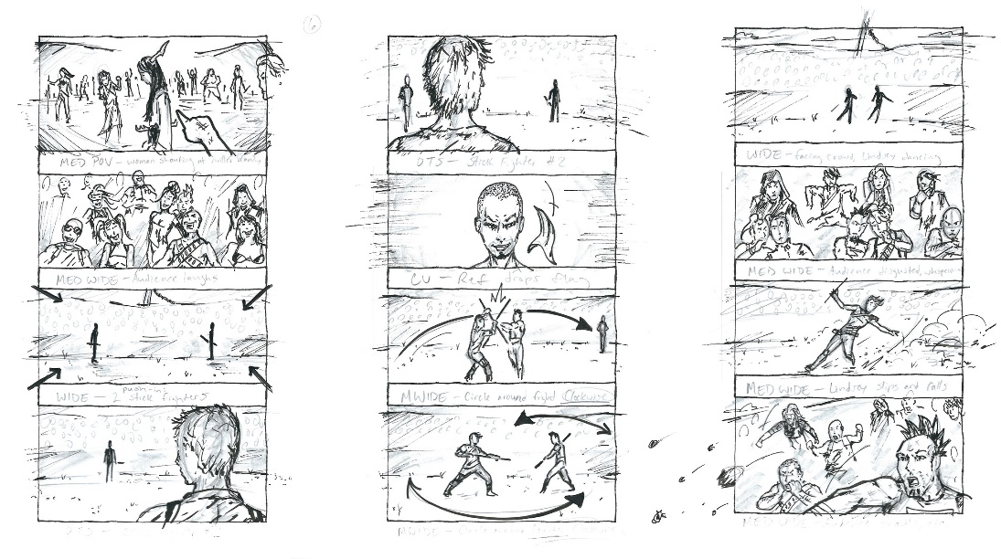

Photo credit: Pond5 blog

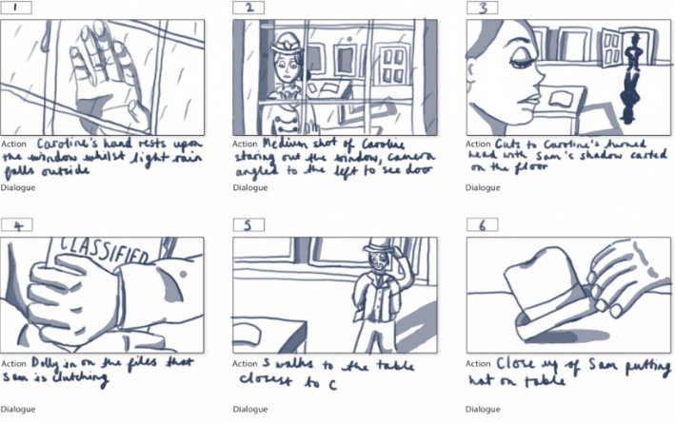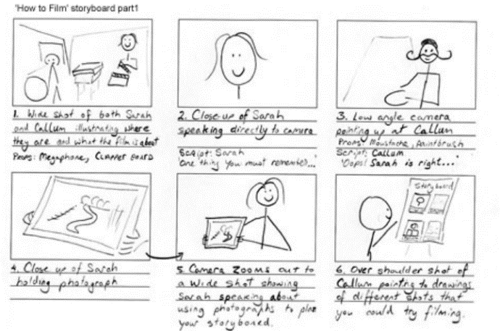

Other storyboards are more detailed and include notes on action, dialogue, camera shots etc.

Photo credit: The University of British Columbia

Photo credit: Natalie Chak

* 1. **Exercise 1**

**Introduction, build-up and resolution**

As we saw in Screenwriting, a story is normally made up by a beginning, a middle and an end:

The **introduction** is when the writer, or filmmaker in this instance, captures the audience’s attention. The beginning introduces the characters and sets the mood and tone of the story and normally offers a glimpse into the theme or problem of a story.

The **build-up** is where most of the story rests. It explains the topic, gives more details on characters and key events and holds the audience’s attention. There is usually a turning point in the middle i.e showing a character’s growth or dealing with conflict.

The **resolution** is where the story comes to a close. The end should portray that the conflict is resolved in the form of a character learning a lesson or coming to terms with what has occurred.

E1, Q1: What do you think the importance of having a ‘beginning’, ‘middle’ and ‘end’ of a story is?

E2, Q2: Freeze frames are motionless images which can be used to create an emotion or an important part of a scene. Why do you think freeze frames are important for a storyboard?

1. **From screenplay to film**
   1. **Exercise 2**

**How do you get a film from a screenplay?**

First of all, you need to read your script and get to know it really well. Understanding all the elements in your story and how they each play a part in telling your story is essential.

**Use your script to answer the questions below:**

E2, Q1: Does your story have an introduction, a build-up and a resolution? State them here.

**Introduction**

___________________________________________________________________________

___________________________________________________________________________

**Build-up**

___________________________________________________________________________

___________________________________________________________________________

**Resolution**

___________________________________________________________________________

___________________________________________________________________________

E2, Q2: Can you list the **nine** main events in your story? (Tip: main events may be when protagonists are introduced, turning points in the storyline, when antagonists change the direction of the story, etc.). You can add as many lines as you need.



E2, Q3: Identify **three** key events and explain how they will engage the audience. You may want to use this exercise to include a strong beginning, middle and end. (Tip: choose scenes that move the plot along)

**Key event 1**

**Key event 2**

**Key event 3**

**3. Creating your storyboard**

**3.1 Exercise 3**

E3: Use the storyboarding template on Google Classroom to create a draft of your storyboard. The template is made of nine boxes, so you may want to use each box to sketch the nine main events of your story. (Tip: sketching is creative rough drawing and it does not need to be perfect)

To create your storyboard, you can:

* use only images
* use images with details on actions and dialogue

(Tip: if you are a visual learner, you might want to create storyboards to remember the storylines of books and films)

* 1. **Camera angles**

Camera angles are used to show different aspects of a film’s setting and characters. Camera angles are important when shaping meaning in film. Different types of camera angles indicate where a camera is placed in relation to the setting or character. The angle of a shot can determine how the audience perceives a character or action. There are many ways to frame a subject in a shot to fixate on the detail in their face to showing them from head to toe. Below are the ten most common shots used for storyboarding: (Boords, 2018).

|  |  |
| --- | --- |
|  |  |
| **Establishing shot**  Normally used at the beginning of a scene and contextualises the character within its environment. | **Full shot**  Show the entire body of a character. It is used to focus on their movements. |

|  |  |
| --- | --- |
|  |  |
| **Point of view shot**  This shot shows the audience what the character is looking at. It allows the audience to understand the scene from the characters point of view. | **Medium shot**  This shows the character from the knees upwards and is used to show the character, environment and can focus on emotions. |

|  |  |
| --- | --- |
|  |  |
| **Close shot**  The characters face takes up the screen and this is used to focus on their emotions. | **Extreme close shot**  This shot is so close that it only focuses on one feature of a character e.g eyes or lips. |

|  |  |
| --- | --- |
|  |  |
| **Up shot**  This shot is taken from below eye level and gives the impression that the character is dangerous or superior. | **Down shot**  This is the opposite of an up shot and is taken from above eye level. It gives the impression that the character is powerless. |

|  |  |
| --- | --- |
|  |  |
| **Over the shoulder shot**  This is taken from behind the shoulder of another character. It is used when characters are in dialogue with one another. | **Two shot**  This shot places characters in the same frame as one another. It gives an insight into their relationship or shows they are equal. |

Images: Karen Mc Guinness

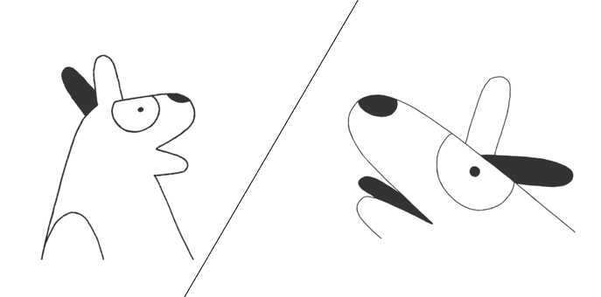

**Shot-reverse-shot**

This shot is the most classical form of camera shot for dialogues. It gives an interesting take on character interaction by placing a shot of both characters side by side instead of moving from one character to another.

**3.3 Exercise 4**

E4: On your storyboard there is a space to add the camera angle of each freeze frame. Label each one with the type of shot you would like to use.

1. **Adding props**

Now that you have thought about the timeline, main events and how they will engage the audience you must think about other elements that are just as important as telling your story. A **prop** is anything that is moveable or portable on set. They can make a scene feel more authentic and help actors carry out their role. Props are challenging for filmmakers but using meaningful props can significantly improve the quality of your film and enhance your storyline.

Props belong to different categories depending on their purpose in the film.

**Hand props** are anything handled or carried by an actor such as: food, bags, candles, weapons, books, keys etc. Hand props are practically anything an actor could pick up and hold.

**Personal props** are props worn or carried by an actor.

**Set props** include furniture. Set props are objects that add to the look of the setting and that the actor can interact with. An example of a set prop is a chair and the actor interacts with the chair by sitting on it.

**Set dressing** consists of similar items that add to the aesthetics of the scene but the actor does not usually handle them. Some examples are: lamps, shelves, pictures, curtains etc.

**Greens** are any plant, live or artificial prop.

**Atmospherics** include fogs, smokes, snow, rain etc.

* 1. **Exercise 5**

E5, Q1: Below is a screenshot from a scene in the film *Pan´s Labyrinth* (Guillermo del Toro, 2006).List five props that appear in this shot:

* .
* .
* .
* .
* .

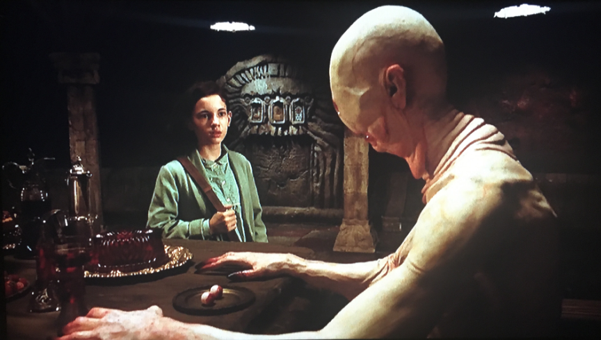

Image: Pan’s Labyrinth, Warner Bros.

E5, Q2: Watch the clip from the film *Pan´s Labyrinth* available via Google Classroom. List six props that are used in this clip, note which category they belong to and their significance.

|  |  |  |
| --- | --- | --- |
| **Prop** | **Category** | **Significance** |
|  |  |  |
|  |  |  |
|  |  |  |
|  |  |  |
|  |  |  |
|  |  |  |

E5, Q3: Fill in the table below with nine props you could use in your film to enhance characters and the background. (Tip: you may want to think about a key prop for each of the nine main events in your story)

|  |  |  |
| --- | --- | --- |
| **Prop** | **Category** | **Significance** |
|  |  |  |
|  |  |  |
|  |  |  |
|  |  |  |
|  |  |  |
|  |  |  |
|  |  |  |
|  |  |  |
|  |  |  |

E5, Q4: There is a space on your storyboard to detail props. Add the props above to your storyboard.

1. **Glossary**

|  |  |  |  |
| --- | --- | --- | --- |
| **English** | **Español** | **Français** | **Deutsch** |
| Camera angles | Los ángulos de cámara | Les angles de prise de vues | die Kamereinstellung |
| Close shot | El primer plano | Le gros plan | die Nahaufnahme |
| Down shot | El plano picado | Le plan plongée | die Aufsicht |
| Draft | El borrador | Le brouillon | die Skizze/ die Vorlage |
| Establishing shot | El plano de establecimiento | Le plan d’ensemble | die Eröffnungsszene |
| Extremely close shot | El plano detalle | Le très gros plan | die extreme Nahaufnahme/  die Detailaufnahme |
| Freeze frames | Los fotogramas congelados | Les arrêts sur image | das Standbild/ die Standbilder |
| Filmmaker | El/la cineasta | Le/la cinéaste | der Regisseur/  die Regisseurin |
| Full shot | El plano entero | Le plan moyen | die Ganzaufnahme |
| Medium shot | El plano medio | Le plan mi-moyen | die Halbnahaufnahme |
| Point of view shot | El plano subjetivo | Le plan subjectif | die Subjektive Kamera |
| Props | Las utilerías/  Los accesorios | Les accessoires | die Requisiten |
| Set | El plató | Le plateau | die Filmbühne/  der Drehort |
| Setting | El escenario | Le cadre | die Kulisse |
| Shot | El plano | La prise de vues /  Le plan | die Aufnahme |
| Sketch | El boceto | Le croquis | die Skizze |
| Storyboard | El guión gráfico/  El storyboard | Le scénarimage/  Le storyboard | das Storyboard |
| Storyline | La trama | L’intrigue /  L'histoire | die Geschichte |
| Up shot | El plano contrapicado | Le plan contre plongée | die Untersicht/  die Froschperspektive |
|  |  |  |  |
|  |  |  |  |
|  |  |  |  |
|  |  |  |  |
|  |  |  |  |

1. **Self-assessment**

After completing the four exercises, tick the column that best represents how you feel about the following statements:

|  |  |  |  |
| --- | --- | --- | --- |
|  | **Not at all confident** | **Nearly there** | **Very confident** |
| 1 I have an idea of what a storyboard is and why it is used in filmmaking. |  |  |  |
| 2 I can divide my own screenplay in three parts: introduction, build-up and resolution. |  |  |  |
| 3 I can select the main events of my own screenplay. |  |  |  |
| 4 I know the names of at least five camera angles. |  |  |  |
| 5 I know what props are and can say the name of three different types of props. |  |  |  |
| 6 I can think of props to enhance my story and my characters. |  |  |  |

1. **References**

Boords (2018), *Understanding 16 types of camera shots and angles with GIFS.* Available at: <https://boords.com/blog/16-types-of-camera-shots-and-angles-with-gifs> [Accessed 21/12/2018]

Del Toro, G. (2006). *Pan’s Labyrinth*, Warner Bros.